VOCABULARY

Writing Concepts – Week 2

- Character – a person (though not necessarily a human being) depicted in a narrative or drama.
- Conflict – In literature, a conflict is a literary element that involves a struggle between two opposing forces usually a protagonist and an antagonist. Internal : In literature and drama, a struggle which takes place within the individual characters mind – External : In literature, a struggle between two or more characters due to some outside force
- Exposition – Exposition is a literary device used to introduce background information about events, settings, characters etc. to the audience or readers. The word comes from the Latin language and its literal meaning is “a showing forth.” Exposition is crucial to any story, for without it nothing makes sense.
- Figurative Language – Using words or expressions with a meaning that is different from the literal interpretation to be more effective, persuasive and impactful.
- Flashback – an interruption of the chronological sequence of an event of earlier occurrence.
- Foreshadowing – a literary device in which a writer gives an advance hint of what is to come later in the story.
- Idiom (examples) – A speech form or an expression of a given language that cannot be understood from the individual meanings of its words
- Personification – A non-human object or being having human-like characteristics
- Plot – the story or sequence of events in something such as a novel, play, or movie.
- Point of View – the perspective on events of the narrator or a character in a story.
- Setting – the period in time and place (surroundings and environment) in which the events of a story are said to occur.
- Summary – a shortened version of a text that highlights its key points, using literary devices such as theme, plot, and setting.
- Theme (link 2: http://literarydevices.net/theme/) (n.) – The subject matter of a conversation, discussion, story, etc. (Also: Central Idea – the subject matter of a non-fictional or informational text, generally contained in the thesis statement.)

- "Identifying theme is typically a bit more difficult perhaps because theme is often confused with plot summary or motif. . . . 'Charlotte's Web (White, 1952) is a story about a pig whose life is saved by a spider' is not a theme statement! It is a plot statement. 'Charlotte's Web is a story about friendship' is also not a theme statement! Rather, it is a statement identifying one of the most important motifs in the story--friendship. 'A theme in Charlotte's Web is that true friendship involves responsibilities as well as privileges' is a theme statement!"

(R. Craig Roney, The Story Performance Handbook. Lawrence Erlbaum, 2001)

Discuss

- Falling Action (n.) – Falling action occurs right after the climax, when the main problem of the story resolves. It is one of the elements of the plot of the story, while others are exposition, rising action, climax, and resolution. Besides, it wraps up the narrative, resolves its loose ends and leads towards the closure.
- Flashback (n.) – Merriam Webster defines flashback as “an interruption of the chronological sequence (as of a film or literary work) of an event of earlier occurrence.”
- Rising Action (n.) – Rising action in a plot is a series of relevant incidents that create suspense, interest and tension in a narrative. In literary works, a rising action includes all decisions, characters’ flaws and background circumstances that together create turns and twists leading to a climax. We find it in novels, plays and short stories. Rising action is one of the elements of plot, begins immediately after its exposition.
- Climax (n.) – Climax, a Greek term meaning “ladder”, is that particular point in a narrative at which the conflict or tension hits the highest point.
- Resolution (n.) – The literary device resolution means the unfolding or solution of a complicated issue in a story. Technically, resolution is also known as a denouement. Most of the instances of resolution are presented in the final parts or chapters of a story. It mostly follows the climax.

Rikki-Tikki-Vocabulary – Week 3

Vocab Concept Card Strategy and Templates

Rikki-Tikki-Tavi Vocab on Quizlet Vocab on SlideShare
- bask (v.) – to be in, or expose oneself to, pleasant warmth; to take pleasure in or derive enjoyment from
- cantonment (n.) – temporary living quarters for troops, especially winter quarters of an army.
- cultivated (adj.) – developed for human use
- consolation (n.). – something that comforts
- cower (v.) – to crouch or shrink away from in fear or shame
- cunning -ly (adv.). – in a clever way that is meant to trick or deceive.
- demise (n.) – death; a ceasing to exist
- devour (v.) – to consume or eat up greedily or enthusiastically
- draggle (v.) – to make something wet and dirty by trailing it along the ground.
- fledgling (n.) – a young bird
- gait (n.) – way of walking or running
- immensely (adv.) – to a great extent; enormously
- impotent (adj.) – powerless; lacking strength
- lash 1.) (v.) – to whip or strike; to scold; to strap down with rope or cord; 2.) (n.) a whip; a blow made by or as if by a whip; an eyelash
- mourn -ful (v.) – to feel or show sorrow or grief because of a loss
- muster (v.) – gather; assemble
- plunged (v.) – move suddenly downward
- quiver (v.) – to shake rapidly with small movements
- rambunctious (adj.) – noisy and lacking in restraint or discipline
- restless (adj.) – not able to be still
- revive (v.) – cause to regain consciousness
- scornful – adj. – with great dislike
- scuttle (v.) – to run quickly, with hurried movements
- sluice (n.) – an artificial channel for water to flow that is controlled by a valve or gate.
- valiant (adj.) – possessing or acting with bravery or boldness
- veranda (n.) – a porch along the outside of a building (sometimes partly enclosed)

ANIMALS

Tailorbird

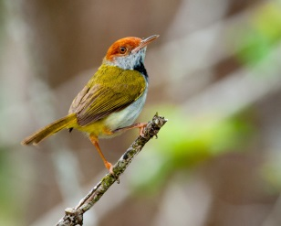

http://www.britannica.com/animal/tailorbird

http://www.oiseaux-birds.com/card-common-tailorbird.html

http://www.naturia.per.sg/buloh/birds/Orthotomus.htm

http://www.naturia.per.sg/buloh/birds/Orthotomus_sutorius.htm

Sound: https://www.youtube.com/watch?v=YpGijm5lWcQ (00:00:22)

Coppersmith

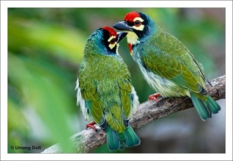

http://kinooze.com/coppersmith-barbet/ (00:00:30)

http://www.indianmirror.com/wildlife/birds/coppersmith-barbet.html#

http://www.oiseaux-birds.com/card-coppersmith-barbet.html

Sound: http://ibc.lynxeds.com/sound/coppersmith-barbet-megalaima-haemacephala/song-male

Sound: https://www.youtube.com/watch?v=9PueKwsHCoc

Muskrat

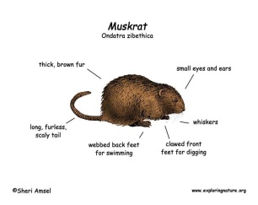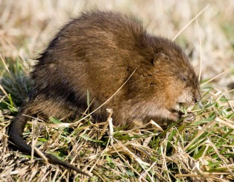

http://www.biokids.umich.edu/critters/Ondatra_zibethicus/

http://www.havahart.com/muskrat-facts#habitat

http://wdfw.wa.gov/living/muskrats.html

http://www.fcps.edu/islandcreekes/ecology/muskrat.htm

http://www.nhptv.org/natureworks/muskrat.htm

Mongoose

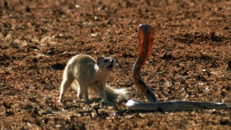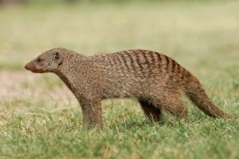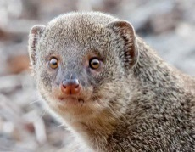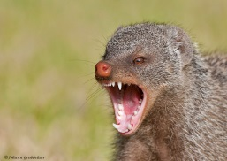

Cobra vs. Mongoose fight - https://www.youtube.com/watch?v=vdg9gkmWsEA

http://animals.nationalgeographic.com/animals/mammals/mongoose/

http://a-z-animals.com/animals/mongoose/

http://www.livescience.com/52565-mongoose.html

http://www.animalfactsencyclopedia.com/Mongoose-facts.html

http://www.encyclopedia.com/topic/mongoose.aspx

Cobra

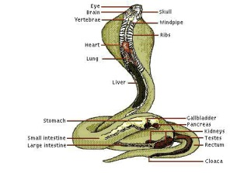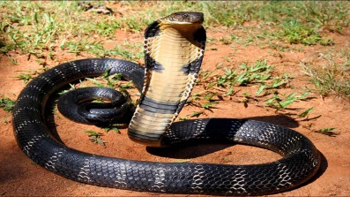

http://www.livescience.com/43520-cobra-facts.html

http://animals.nationalgeographic.com/animals/reptiles/king-cobra/

http://cobras.org/cobras-all-you-need-to-know/

